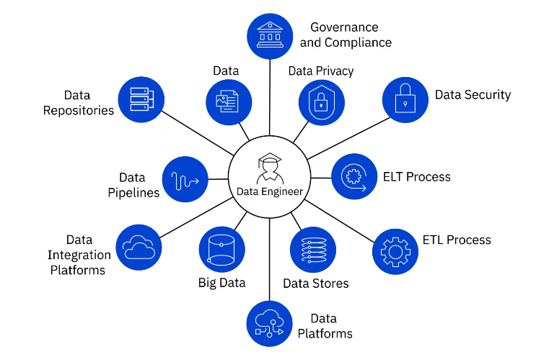

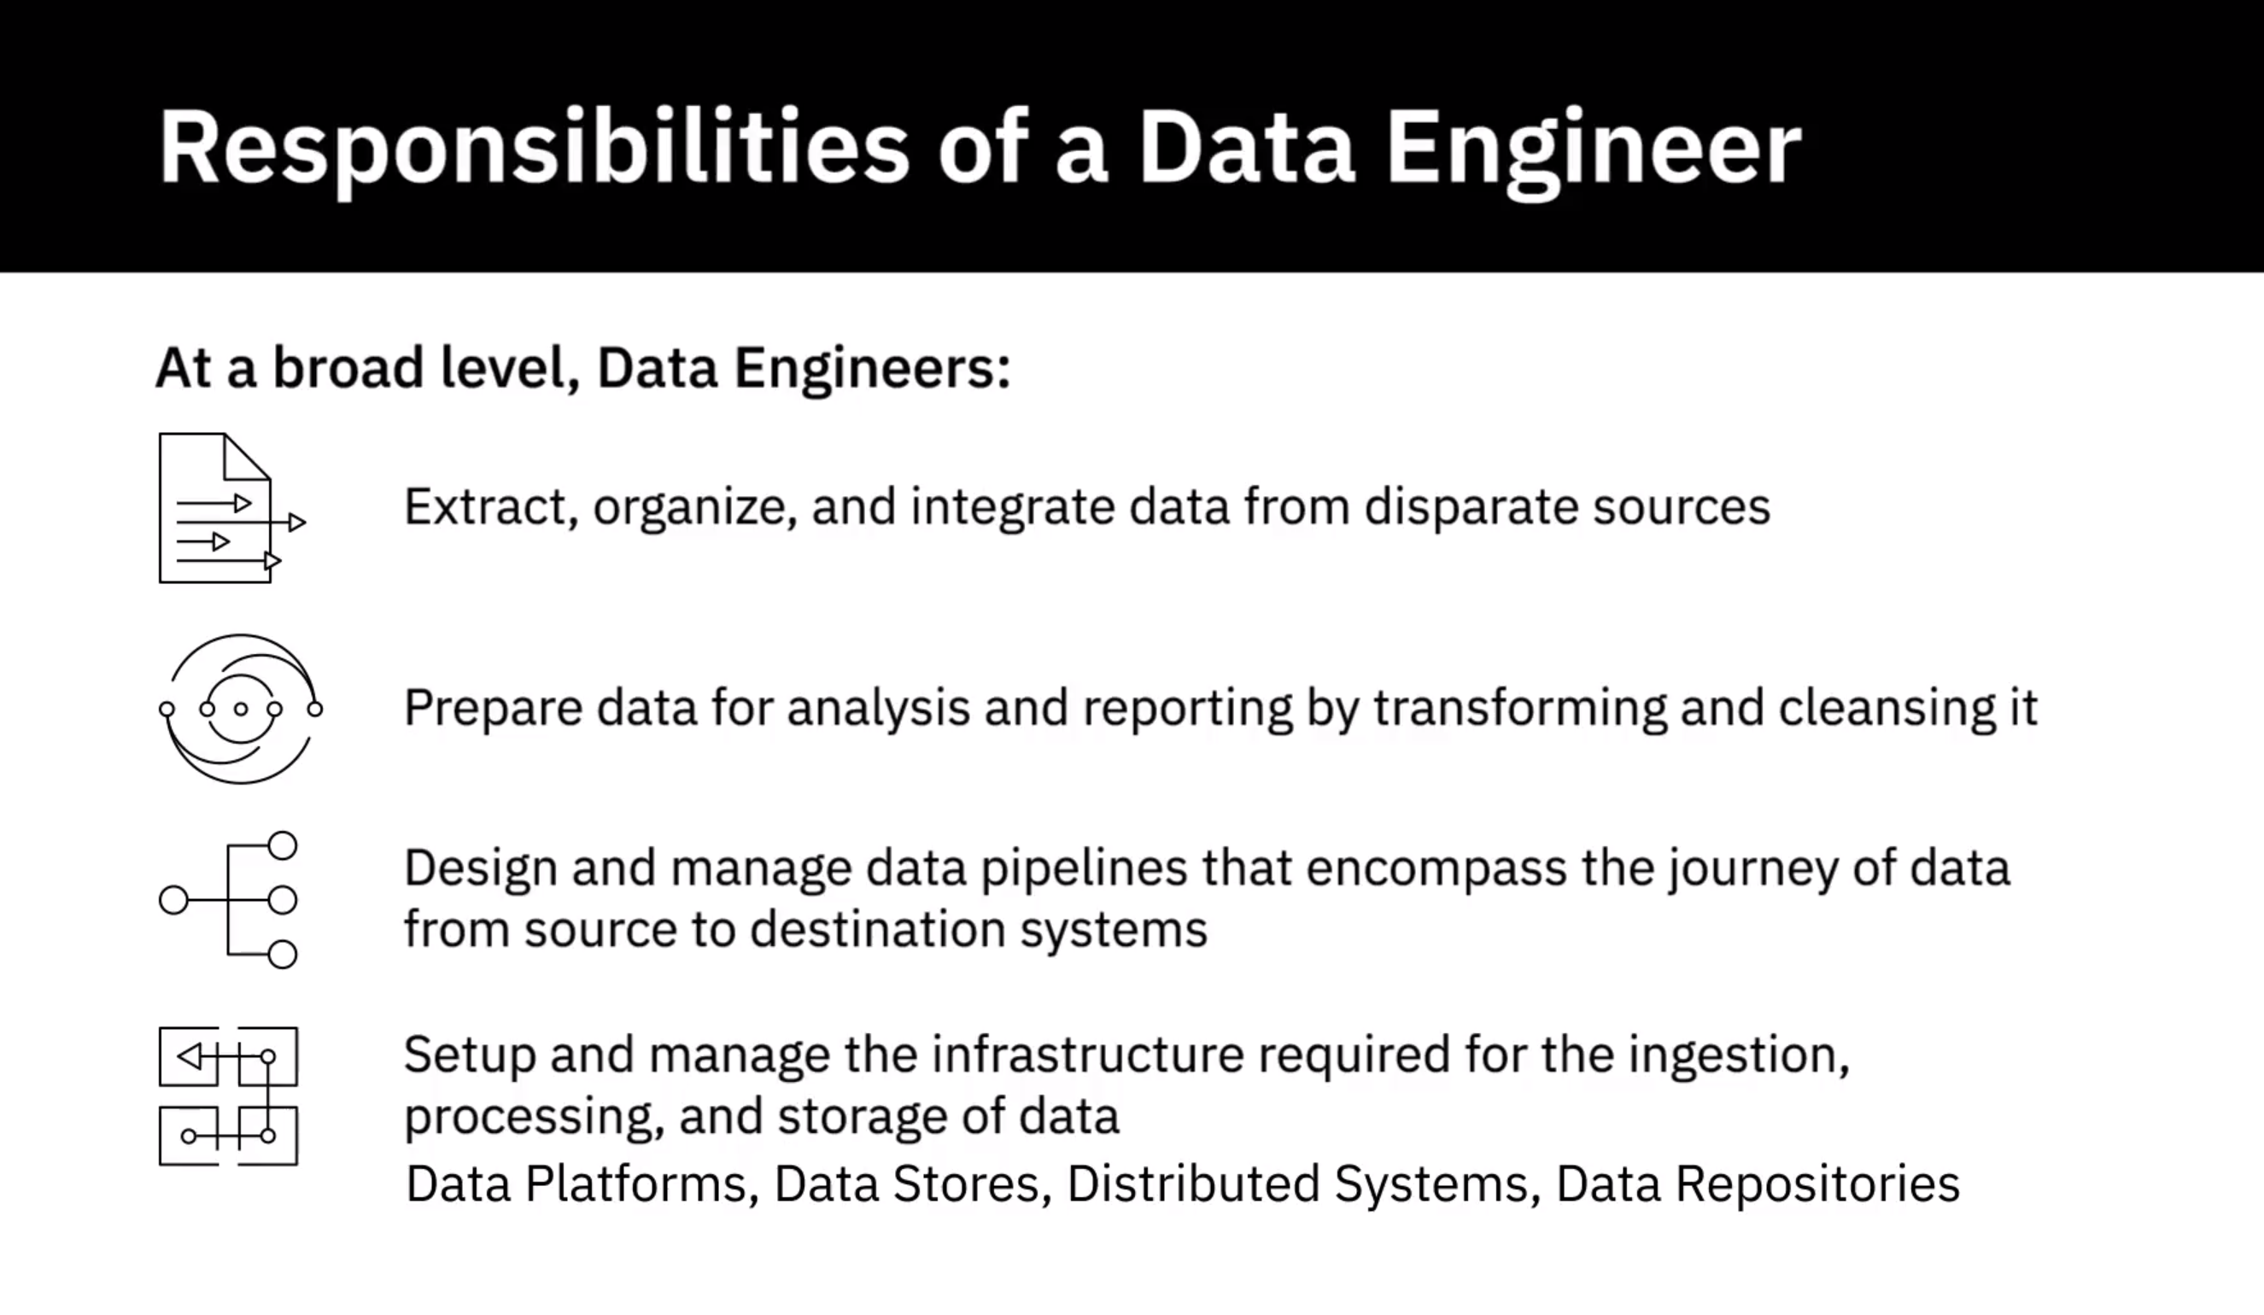

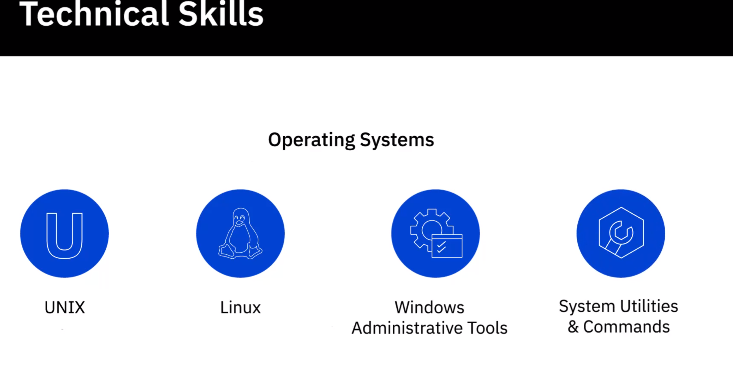

Functional Skills:

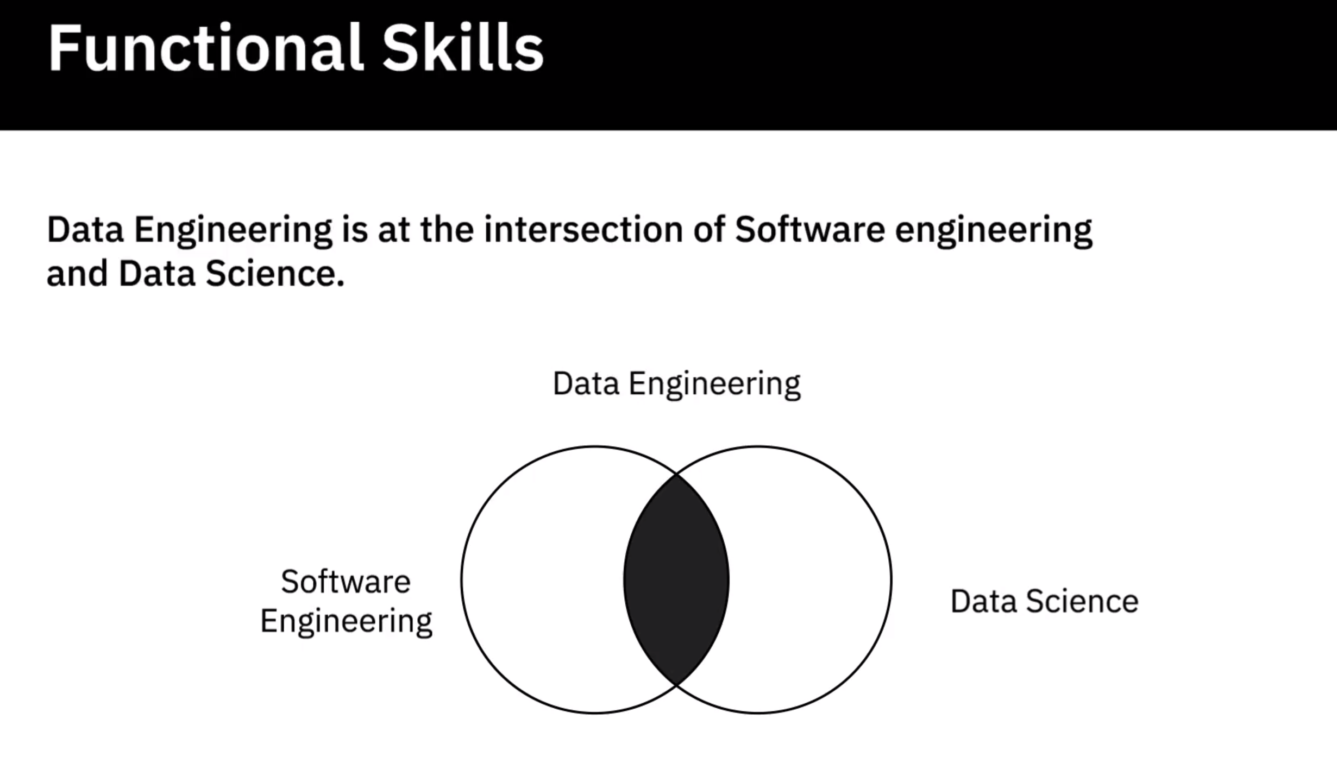

**Video: Viewpoints: Skills and Qualities to be a Data Engineer (6:58)**

**Video: A Day in the Life of a Data Engineer (3:37)**

**Video: Overview of the Data Engineering Ecosystem (4:53)**

Data Sources

Data Repositories

Data Integartion

Data Pipeline

Languages

BI and Reporting Tools

**Video: Types of Data (4:02)**

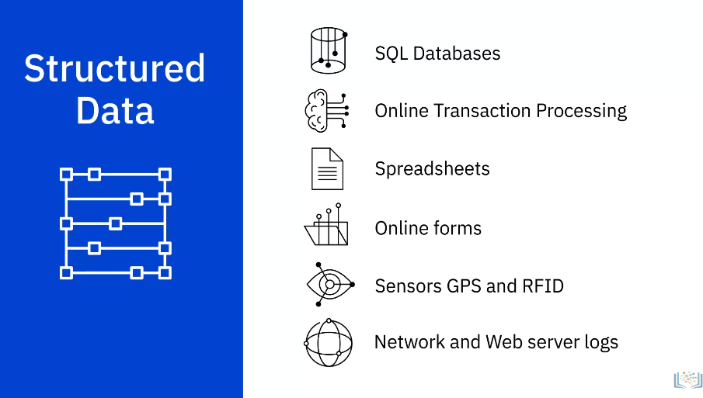

1. Structured data has a well-defined structure or adheres to a specified data model
2. can be stored in well-defined schemas such as databases
3. and in many cases can be represented in a tabular manner with rows and columns.
4. **Structured data is objective facts and numbers that can be collected, exported, stored, and**
5. organized in typical databases.
6. Some of the sources of structured data could include:
7. SQL Databases and Online Transaction Processing (or OLTP) Systems that focus on business transactions
8. Spreadsheets such as Excel and Google Spreadsheets
9. Online forms
10. Sensors such as Global Positioning Systems (or GPS) and Radio Frequency Identification
11. (or RFID) tags; and Network and Web server logs.
12. You can typically store structured data in relational or SQL databases.
13. You can also easily examine structured data with standard data analysis methods and tools.